# Rally Hosting Background

If you decide you would like to get more involved with your club and host a rally, the first thing to know is that there are no hard and fast rules. There is no fixed length, no minimum or maximum on the number of activities to offer, and no set fees to charge. Each rally is its own event, and as the rally host you have complete control over what, where, and when things go on!

This guide is intended to provide ideas for your rally, what to be aware of, and help you plan for a successful rally.

Wally Byam Caravan Club International (aka Airstream Club International or ACI) defines four types of rallies:

* Flash
* Unit
* Regional
* International

This guide covers Flash and Unit rallies. Regional and International rallies are typically planned and executed by committees rather than individuals.

**Flash rallies** are more of an informal get-together for members. They do not usually have a lot of structure or organized activities, don’t normally have a rally fee, and only exist as a type to provide a mechanism for approval at the club level for insurance purposes.

**Unit rallies** are planned by a rally host. They are scheduled well ahead of time, added to the club schedule, and may have organized activities associated with them. These activities may include excursions to explore local culture, dining at nearby restaurants or supper clubs, or outdoor activities such as hiking or biking. Unit rallies are publicized within the unit, on the Airstream Club International (ACI) event calendar, ([Event Calendar | ACI (airstreamclub.org)](https://airstreamclub.org/events?from=&to=&type=-1&state=-1&club=45933&list=1) for the Wisc-UP Airstream Club), and in the Blue Beret magazine (Blue Beret pulls information from the Airstream Club International event calendar each month).

# Rally Concepts

### Theme

If you look at the caravans and major rallies at regional and national levels, you will see that they normally have a theme - a focus for planned activities during the event. Having a theme for your rally helps give it an identity and helps people who may see it advertised get a quick understanding of what it is about. A theme does not have to involve a major local event, it can simply be something like getting to know the area or the culture where the rally is held. The theme can also be built around the attractions or activities for which the area is known.

You don’t have to have a theme. People are just happy to get out and enjoy the friendship and camaraderie of fellow Airstreamers, and that is enough. Happy hours and morning coffee are good ways to gather people for some in-person social networking.

### Rally Expenses and Fees

If you plan activities that need to be paid prior to or during the rally, you will have to figure out what the per person or per event costs (or a combination of the two) will be for those activities. In many rallies, there is a fee collected to purchase food or supplies that will be consumed during the rally. Hosts are not expected to pay out of their own pocket for rally expenses. While we prefer to have attendees make their own reservations for camping and any optional activities that are planned, like a boat cruise, festival attendance, bus transportation, and so on, sometimes the fees must be collected ahead of time and paid to the vendor in one payment rather than using individual reservations and payments. There may also be fees incurred for meeting rooms or minimum charges at a restaurant, or for shelters at campgrounds.

Whatever is appropriate for the activities you plan should be listed, and then an estimate of the per person and or per event costs can be estimated. If the vendor charges per person or per trailer, then a good rule of thumb is to estimate 20-25 trailers and/or 35-45 people. The goal should be to get as close as possible to the actual cost. We aren’t trying to make money at our events, but we don’t want to lose money on them either. Hosts are NOT liable for spending more than they collect but try to be close.

Once the per person and event costs are established the event can be published on the Airstream Club International website and a registration page can be built on the Wisc-UP Airstream Club Registration site to allow collection of any rally fees or head counts that are necessary. Our unit webmaster publishes the event on our ACI website and our registrar sets up a skeleton registration event. The host is then responsible for adding information and publishing the event on the Wisc-UP Registration website.

The following pages go into more detail about setting up a rally.

# Rally Planning Guide

Hosting a rally should be enjoyable for both the hosts and attendees! The goal of this guide is to provide some organization for all the different tasks rally hosts face and help make your rally successful.

## Steps to Host a Rally

1. Decide on the location, an approximate date, and what activities would be available. If using a campground, check that a rally would also work with their calendar, and if they would be willing to set aside sites.
2. Contact the current 1st Vice President and discuss your ideas. If the rally fits in the next year’s calendar, the 1st VP will add you to the schedule and give you the go-ahead to start planning. If you are planning for the current year talk to the President. Now is the time to ask another member to help host the rally!
3. It is time to lock down some details with the campground. If private, it’s best if attendees are permitted to contact the campground directly and make their reservations. Other examples of locations would be fairgrounds, private land, state/county/municipal parks. Will the location have a pavilion or shelter to use for gatherings during rain? If a deposit is required, you should contact the treasurer to arrange payment directly to the venue. Rally hosts are not permitted to make the deposit payment from their own pocket.
4. Brainstorm with your cohosts to prepare a preliminary rally schedule. Make lists of possible activities, research costs for tours, and make meal decisions. This planning will be necessary to set your rally fee. Make an outline of your weekend schedule. Remember, this is a preliminary schedule, changes will happen!
5. Set your rally fees! What meals do you want to organize for the group? Potluck? Taco Bar? Breakfasts? Coffee? Catered Dinner/Pizza? Bring your meat and a side to share? Or all meals on your own! Use your imagination and choose something you enjoy and are comfortable providing!

Now to estimate those rally fees.

**Breakfasts**: Estimating $12 per adult for a three-breakfast rally is a good starting point. (Based on 2025 prices.) This will provide a decent amount of food for the group. If you have something special in mind that may be more expensive, just adjust the allowance to meet your estimated cost.

**Dinners:** Do you want to provide food? Estimate the cost per person, for example at a popular local pizza place. How many people will their large pizza feed? Use an average large pizza price and divide by servings. Again, $15/adult may provide an adequate pizza budget! Do this estimation method for any food you want to provide your rally guests. And round up the head count a bit to ensure adequate quantity.

**Rally plates/utensils/napkins**: You decide if you want to provide. Estimate $5-7/ person (based on 2025 prices) to include all breakfasts and dinners.

Costco is an excellent source for reasonably priced food/plates/etc. in rally quantities.

Once you have decided all you will provide, add up the costs per person, and that will be your rally fee per adult for food.

**Other Rally Fees:** Some locations may have a shelter or building that we can use but charge a rental or reservation fee to allow your rally sole use. If you want to use the facility, divide the cost for the rally by the number of adults you estimate will attend. Add that per person estimate to the rally fee calculation.

Is there an activity with a cost that you want the entire group to attend? A local tour, a speaker coming on site, a museum, a boat ride… then add the admission or fee/donation (divided among attendee estimate if the cost is for the group) to the rally fee.

**Estimating Rally Attendance:** For the rally expenses, you will need to estimate the rally attendance. On average, rallies will attract 20-25 units, 40-50 adults. Your rally may be different - a very popular location, a special event occurring during your rally, or even a small venue that would limit parking to 15-20 units. Use your best judgement, or ask the Wisc-UP Registrar or 1st VP for help!

If you would like to have a group meal at a local restaurant, like Friday Fish Fry, and have everyone pay their own tabs, add a zero-cost price option in the Wisc-UP Airstream Club Registration System to collect the number of interested attendees. This will give you a head count to keep the restaurant informed. This same method can also be used to track interest in other activities without collecting money.

Extra events can be handled in other ways too. First option is that people can pay their own admission at the activity. This works well if people choose to come during their free time and will arrive at different times. The second option would be to list an activity with the cost as optional price on the Wisc-UP Airstream Club Registration System.

These activities may be more expensive, such as a scenic boat ride and the group would attend at a specific time together. The ticket cost would be paid at the time of registration. This type of prepaid activity will require your coordination with the treasurer to receive a check prior to the event to pay the venue.

An example of estimating rally fees:

|  |  |
| --- | --- |
| Breakfast allowance per person (3 mornings) | $12 |
| Firewood for evening campfire (two nights) | $10 |
| Dinner allowance per person (Pizza/salad night) | $15 |
| Plates/napkins/utensils/tablecloths/decorations | $6 |
| Building fee ($100/50 attendees) | $2 |
| Local artisan demo ($200/50 attendees) | $4 |
| Total rally fee | $49 |

**Children’s Rally Fees:** Set your children’s rally fees if they are different from adults. You can also set the age where a child is considered an adult from a rally fee perspective. If you need assistance, ask the 1st VP or Wisc-UP Registrar.

The goal of every rally is to break even. No large overage, no large loss. Our club asks rally hosts to do their best to estimate expenses and collect adequate rally fees. However, no rally host is responsible for any rally’s financial loss.

1. Publicize your rally. Write a few paragraphs about your rally, including the dates, location, activities, and rally fees. This information can be shared in several places: the Wisc-UP Newsletter, the Airstream Club International Website (and Blue Beret magazine), the Wisc-UP Registration website, and on Facebook.

Email a copy of your write-up to the Wisc-UP Webmaster. This will get your information in the event section of our Airstream Club International website and an event created on the Wisc-UP Registration website. Plan to send a general description and dates as soon as possible. This can be updated later to include more details if needed.

Send your rally information to the Editor of the Wisc-UP Newsletter 4-6 months ahead of the rally. All events will appear in every newsletter, under the heading “Upcoming Events”, but your write-up is what will provide details and entice members to attend! This can be sent earlier if members need to secure campsites, etc. Two to three months ahead of rally, a second article for the newsletter would inform newer members and forgetful older members of your exciting rally and remind them to register on our website.

Create an event on the Wisc-UP Facebook Page. If you need help, contact an administrator of the Facebook page.

Add all the rally information and fees to the Wisc-UP Registration website. The Wisc-UP Registrar will help with any questions you have or best ways of setting up your rally pricing. Once you are happy with the information for your rally on the registration site it is your responsibility to publish the event so that people can register to attend. You do this by setting the “Publish” field to “Yes” and clicking the SAVE button.

Build a roster worksheet and an email list to contact attendees (both can be downloaded as often as you like from the registration website once people have started to register). This is important to keep attendees informed! If you build your roster based on campsite information the campground shared before you published your rally on the Wisc-UP Registration website, you can send an email to those with campsites, confirming they have a site and asking them to register. However, we recommend getting the rally published as soon as possible and then using the downloads available to hosts. This will avoid reconciliation between your manual roster and the registration system roster.

**An “email blast”:**  write the body of an email with your rally information. Send the email to our Wisc-UP Webmaster and ask them to forward your email to all members. The Webmaster will cut and paste your written information into a new email that is sent to all members. Remember, your write-up is what will be sent, do not ask the Webmaster to edit your work.

Use your roster worksheet or the Wisc-UP Registration website to track that rally fees have been paid by all members who have a campsite. Every time someone registers online, you will receive an email from our Wisc-UP Registrar. Make sure everyone has a site and has paid their rally fee. One week before your rally, download attendee information from the registration website and verify that your roster matches if you’ve elected to make one separate from the registration website. Contact the Registrar with any discrepancies. Rally hosts also must register and pay the rally fees.

Email all attendees a copy of the Rally Program/Schedule. Use your email list to notify everyone of changes, or to send out updated programs. Allow enough time for people to plan potluck contributions, Happy Hour snacks, etc.

1. **Financial/Accounting Responsibility:** Bookkeeping requirements for rally expenses will be determined by the club treasurer. Keep all receipts for any rally expenses you paid directly. Use the Rally Accounting Form to list and track all income and expenses. When the rally is complete, send the form along with copies of all receipts to the treasurer for reimbursement. This can be submitted electronically via email, with scanned receipts. Discuss with the treasurer how to forward any cash received during the rally.
2. Donations, WISC-UP 4 GOOD. You may want to select a local cause to benefit from a group activity or financial donation. Allow for free will donations via the registration website or ask the Treasurer to forward the agreed upon amount or the donations to the chosen charity. The goal is to prevent rally hosts from having to collect and disburse cash.
3. Enjoy the rally! After all the preparations, try to relax and enjoy your rally. Welcome participants when they arrive by handing out Welcome Packets with local attraction brochures and maps provided by the local Visitor Center or Chamber of Commerce. Introduce yourselves to new members and record arrivals on your rally roster.

Ask rally participants for help when you need it; you will have many offers. Some regular activities, such as introductions by everyone during the first happy hour, are great ice breakers. Again, do things you enjoy. Set up game night, play a movie, or have a jam session with our talented musical members.

What did you enjoy at a past rally? What did you not enjoy? Our members have varied interests and talents, just waiting for you to discover!

## 2026 Contact Information

|  |  |  |
| --- | --- | --- |
| President | Jenny Bibler | [Jenny.giles@att.net](mailto:Jenny.giles@att.net) |
| 1st Vice President | Zachary Lee | [zacharyalee@gmail.com](mailto:zacharyalee@gmail.com) |
| Treasurer | Kurt Jorgensen | [hillviewkurt72@gmail.com](mailto:hillviewkurt72@gmail.com) |
| Wisc-UP Webmasters | Bob Manak / John Cooper | [webmaster@wisc-up.org](mailto:webmaster@wisc-up.org) |
| Wisc-UP Registrar | John Cooper | [john@wisc-up.org](mailto:john@wisc-up.org) |
| Newsletter Editor | Ed Emerick | [emerick4425@gmail.com](mailto:emerick4425@gmail.com) |
| Facebook Administrator | Sandy Emerick | [semerick4425@gmail.com](mailto:semerick4425@gmail.com) |

Current Officers and their contact information is available on the Airstream Club International website at <https://airstreamclub.org/wisc-up/wisc-officers>

## RALLY CHECKLIST

* Select location, date, activity highlights
* Contact 1st Vice President (next year) or President (current year) for approval, find rally co-hosts
* Coordinate details with rally location/campground
* Create basic outline of rally activities, meals, etc. (aka Rally Schedule)
* Set your rally fee
* Publicize your rally:
  + Send rally write-up to Wisc-UP Webmaster
  + Send rally write-up to Newsletter Editor
  + Add Event to our Facebook Page
  + Update registration information and pricing on the Wisc-UP Registration website
* Complete and share the Rally Schedule with attendees
* Track all expenses, save receipts and submit them to Treasurer for reimbursement
* WISC-UP 4 GOOD: Decide if you want to support a local charity, and how you would like to provide support. *Optional*.

## Wisc-UP Registration Website

The registration website has been mentioned several times in the rally guide. This section of the guide is to help hosts understand what information they must provide and where it goes on the registration website so that members may register for events, and the hosts have visibility into who has registered and who has paid for their registration.

The Wisc-UP Registration website is at <https://www.wisc-up.org>.

The website requires a login. This login is not connected in any way to the login you have at the Airstream Club International website. The login is required because we publish our club directory on the registration website. It should not be available to anyone who is not a member of the Wisc-UP Airstream Club, and we protect it using the login.

If you have not set up an account on the Wisc-UP Registration website, use the link above and go to the website. The login screen looks like this:

You can click on either the “Sign-up” menu option at the top or the “Need to sign up?” link to set up an account. You only need to set up an account once. After your account is set up you can just fill in your credentials (email address and password) and click the LOGIN button.

The system requires unique email addresses for each account, so if you normally use the same email address for both you and your partner, only one of you will be able to set up an account.

When you click on either of the sign-up options, the screen below will appear:

All but two fields are self-explanatory. BRN is your Big Red Number that Airstream Club International assigns when you join. Home Club is the local club where you are a regular (as opposed to an affiliate) member. If you don’t have a home club defined in your ACI member profile, which means you are a member-at-large, select Member-At-Large as your home club.

Click the JOIN button once your information has been entered and the system will verify what you entered and create an account for you on the Wisc-UP Registration website. Once your account is created the system will redirect you to your account dashboard.

If you are a Member-at-Large and would like to make Wisc-UP your home club, contact ACI by phone (937-596-5211) or by sending an email to [membership@airstreamclub.org](mailto:membership@airstreamclub.org) and requesting that Wisc-UP be set as your home club. This will change your membership type in Wisc-UP from affiliate to regular and give you the right to vote in Wisc-UP business meetings. Voting rights are the only difference between affiliate and regular memberships.

Here is a sample dashboard:

Your dashboard shows events you have registered for, open events that you have NOT registered for, and any events where you are assigned as the host. When you send the webmasters your rally information the first time, they will set up an event for you on the ACI website under the Wisc-UP event page. They will also create a skeleton event on the registration website for you to fill in with your event details and pricing. You access your event by clicking on the EDIT button under OPTIONS for your event.

The REGISTRATIONS button lets you see who has registered for your event and lets you download their information and a list of email addresses for attendees. At this point the event is not yet published, so nobody will see it in their dashboard under open events, and nobody can register. Here is the EDIT view.

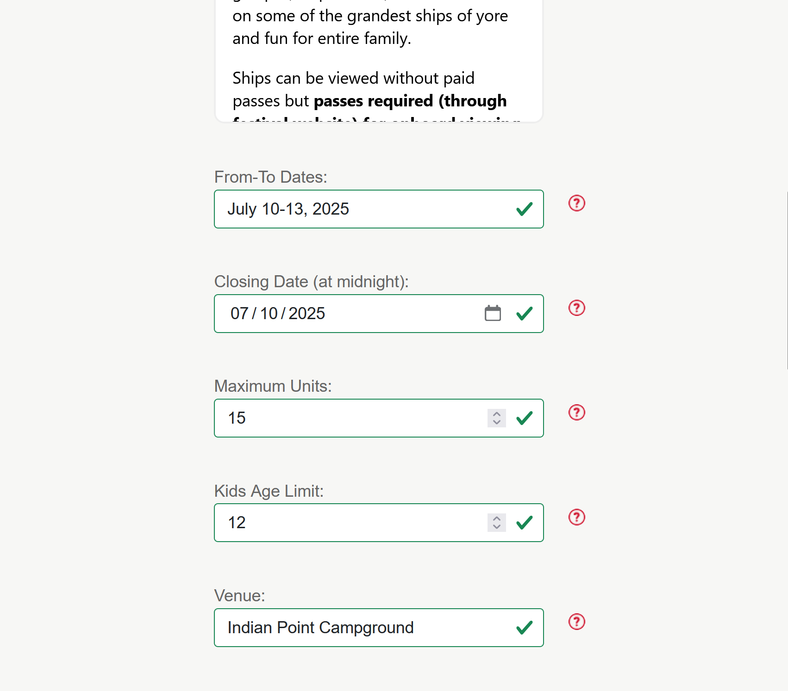

There is quite a bit of information for the host to provide. Some of it will be filled in by the registrar when the event is first created, but most fields must be filled in by the host. Since most people hosting do not host all the time there are little circles with a question mark inside to the right of each field. If you click on one of these circles it will explain what is supposed to be in that field.

The two large boxes allow you to use bold and italics to highlight parts of the text, and a link button allows you to insert links to other websites or email addresses. You can update the event information repeatedly as more is known.

There are two buttons at the top of the screen.

VIEW REGISTRATIONS allows you to see who has registered for the event and download that information. VIEW PRICING allows you to see what pricing has been set up, and to add or edit pricing information. Here is the VIEW PRICING screen showing three prices.

Note the two optional pricing entries with zero prices. These are to collect headcounts.

If you click ADD PRICE or EDIT on one of the price entries, the following screen appears. ADD PRICE will show empty fields. The screen below is for the first price entry on the screen above.

Note the circles with question marks again. If you don’t know what a field is for, click on the circle next to that field for help. When you have entered all the information click on UPDATE to save this price. You can EDIT and change the pricing information any time, but if you have Published the event and people have already signed up, it will get ugly trying to figure out who you need to collect additional money from or who needs to receive a refund. **Best practice is not to make changes after the event is published.**

If we go back to the EDIT page for the event (top part shown below) and click VIEW REGISTRATIONS,

The list of people who have registered will be shown:

While this screen does not show what prices were signed up for, clicking DOWNLOAD REGISTRATIONS will download a .CSV file that you can open in your spreadsheet program to see all the options. This file (opened in Excel) is partially shown below.

This worksheet does not total the counts for each option for you, but you can add totals using the Excel function SUMIFS as shown below:



This formula totals the Adults range (D3:D64) value when the Option range (C3:C64) = “Rally Fee”. Here are the other two formulas:

The DOWNLOAD EMAILS button allows you to download just the emails for people who have registered for your event. The downloads will go into your Downloads folder as .CSV files. You can cut and paste the emails to send updates or reminders to the registrants, and you can download the data as often as you like. You are in control!